Appendix S1. Robbins, CJ, JM Sadler, D Trolle, A Nielsen, ND Wagner, JT Scott. Does polymixis challenge prediction of dissolved oxygen dynamics in south-central US reservoirs?

**Section 1: Expanded modeling details**

For each of the linear, Lasso, and random forest models, we selected a final model from candidate models fit with different predictor sets and tuning parameters (for lasso and random forest). Predictors for each model included depth, day of year, time of day, water temperature, and weather variables (air temperature, north wind velocity, west wind velocity, barometric pressure, dew point temperature, and cloud cover fraction). We compared predictor sets with 0, 1, 6, 12, 24, 36, 48, 72, and 144 hour lagged water temperature and weather data variables, in addition to the same predictor sets allowing for three-way interaction effects among time of day, depth, and each of the weather variables and water temperature. Each numeric predictor was normalized to a mean of 0 and standard deviation of 1. Linear models were fit with lm() in base R (R Core Team 2023), lasso with glmnet::glmnet() (Tay et al. 2023), and random forest with ranger::ranger() (Wright and Ziegler 2017) .

The following final predictions sets and hyperparameters were chosen for linear regression, lasso, and random forest using 10-fold cross validation (see Methods): 1) Linear regression with non-interacting predictors lagged by 6 hours; 2) Lasso with interacting, non-lagged predictors and a regularization parameter lambda = 1x10-10, essentially collapsing the model to a linear regression; 3) Random Forest with non-lagged, interacting predictors and parameters min_n = 3 and mtry = 30.

LSTM is a type of recurrent neural network.

WET is a process-based numerical simulation for lakes consisting of a hydrodynamic model (GOTM, General Ocean Turbulence Model) coupled to an ecodynamics model via FABM, the Framework for Aquatic Biogeochemical Models. Detailed model description can be found in Schnedler-Meyer et al. (2022). Briefly, WET simulates the physical, biogeochemical, and ecological components of a lake given inputs of meteorological data, inflows, and inflow chemistry for N and P. WET is a 1-dimensional model, simulating one-meter vertical layers across which water physically interacts. Each layer consists of an interacting water and sediment compartment, the sizes of which are determined by hypsograph.

We calibrated WET parameters using the Parallel Sensitivity and Auto-Calibration (parsac) tool in python (Bruggeman and Bolding 2020). The parameters we chose to calibrate were sensitive across previous model applications (Nielsen et al. 2014, Andersen et al. 2020). Parsac uses the differential evolution algorithm to search sets of parameter values to optimize the likelihood of model predictions given real observations (e.g., of DO) by running simulations with different parameter values. Each simulation was run with a spin-up period of 5 years. The space of individual parameters are manually narrowed based on the results of calibration runs, and this iterative routine is stopped when parsac can no longer improve the likelihood with new parameter value sets. Because water temperature is caused by physical constraints such as hydrodynamics and heat flux that are precursors to predicting DO (and not additionally caused by biogeochemistry, Soares and Calijuri 2021), we first calibrated WET using water temperature observations to narrow suitable physical parameters in GOTM (short-wave radiation scale factors and e-folding depths, wind velocity scale factors, and minimum turbulent kinetic energy). After this initial calibration produced good estimates of temperature (R2 > 0.95; Arhonditsis and Brett 2004), we re-ran the parsac calibration procedure using DO as the observation data for the likelihood function. This second routine therefore focused on adjusting the remaining biogeochemical and ecological parameters. We used the model purely for DO prediction, so we did not consider predictions for other compartments (e.g., phytoplankton characteristics) except that the parameter spaces controlling those compartments were kept within realistic bounds.

**Section S1: References**

Andersen, T. K., A. Nielsen, E. Jeppesen, F. Hu, K. Bolding, Z. Liu, M. Søndergaard, L. S. Johansson, and D. Trolle. 2020. Predicting ecosystem state changes in shallow lakes using an aquatic ecosystem model: Lake Hinge, Denmark, an example. Ecological Applications 30:e02160.

Arhonditsis, G. B., and M. T. Brett. 2004. Evaluation of the current state of mechanistic aquatic biogeochemical modeling. Marine Ecology Progress Series 271:13–26.

Bruggeman, J., and K. Bolding. 2020, November 19. parsac: parallel sensitivity analysis and calibration. Zenodo.

Nielsen, A., D. Trolle, R. Bjerring, M. Søndergaard, J. E. Olesen, J. H. Janse, W. M. Mooij, and E. Jeppesen. 2014. Effects of climate and nutrient load on the water quality of shallow lakes assessed through ensemble runs by PCLake. Ecological Applications 24:1926–1944.

R Core Team. 2023. R: A language and environment for statistical computing. R Foundation for Statistical Computing, Vienna, Austria.

Schnedler-Meyer, N. A., T. K. Andersen, F. R. S. Hu, K. Bolding, A. Nielsen, and D. Trolle. 2022. Water Ecosystems Tool (WET) 1.0–a new generation of flexible aquatic ecosystem model. Geoscientific Model Development 15:3861–3878.

Soares, L. M. V., and M. C. Calijuri. 2021. Sensitivity and identifiability analyses of parameters for water quality modeling of subtropical reservoirs. Ecological Modelling 458:109720.

Tay, J. K., B. Narasimhan, and T. Hastie. 2023. Elastic net regularization paths for all generalized linear models. Journal of statistical software 106.

Wright, M. N., and A. Ziegler. 2017. ranger: A Fast Implementation of Random Forests for High Dimensional Data in C++ and R. Journal of Statistical Software 77.

**Section 2: Supplementary Figures**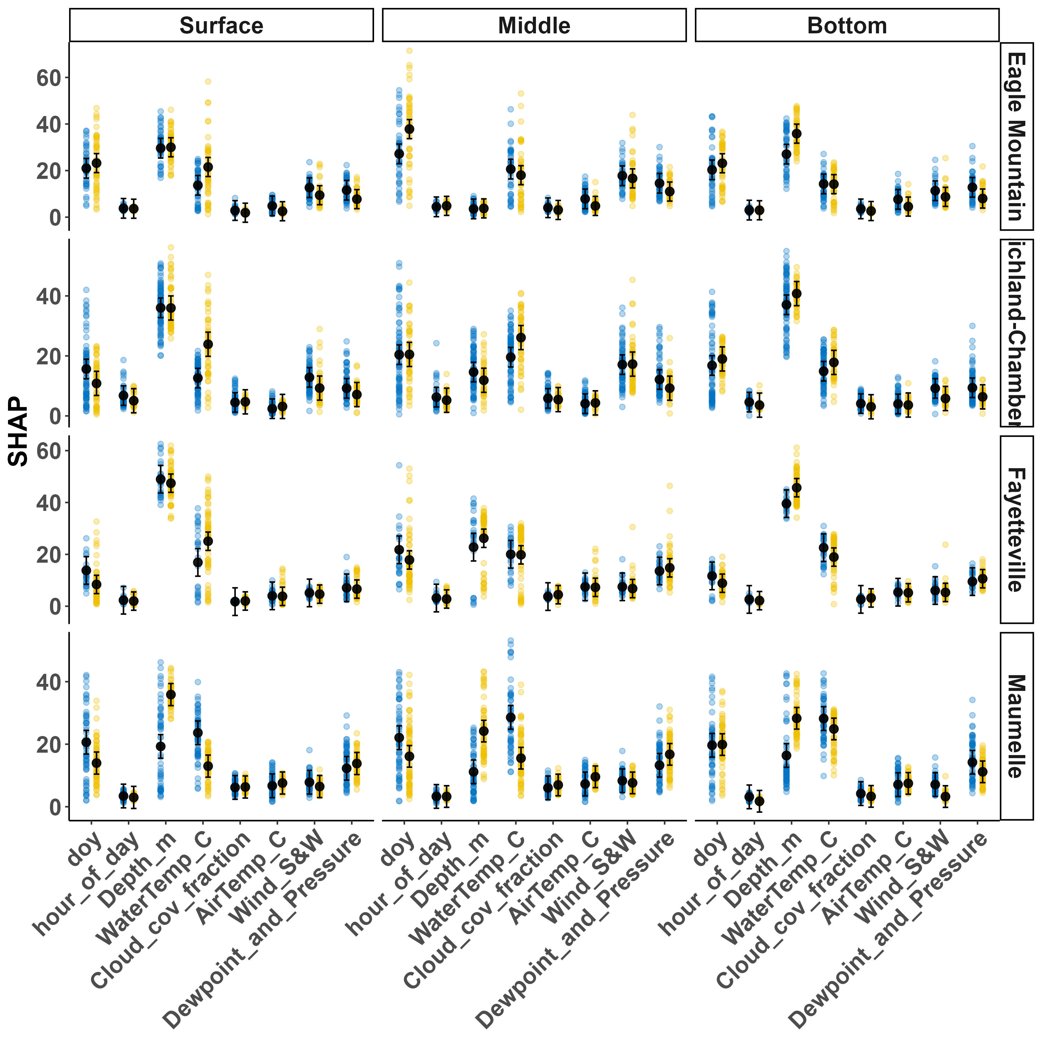

Fig. S1. Shapley Additive exPlanations (SHAP), normalized as percentages, for features (predictors) used in predicting dissolved oxygen at surface (0 m), middle (5 m) and bottom (8.5-10 m; see Methods) vertical locations at four reservoirs. SHAP values are normalized as percent contribution to a given prediction. Small colored points are daily-aggregated SHAP during cool (blue) and warm (gold) seasons. Black points and error bars are estimated marginal means and 95% confidence intervals from a linear model.

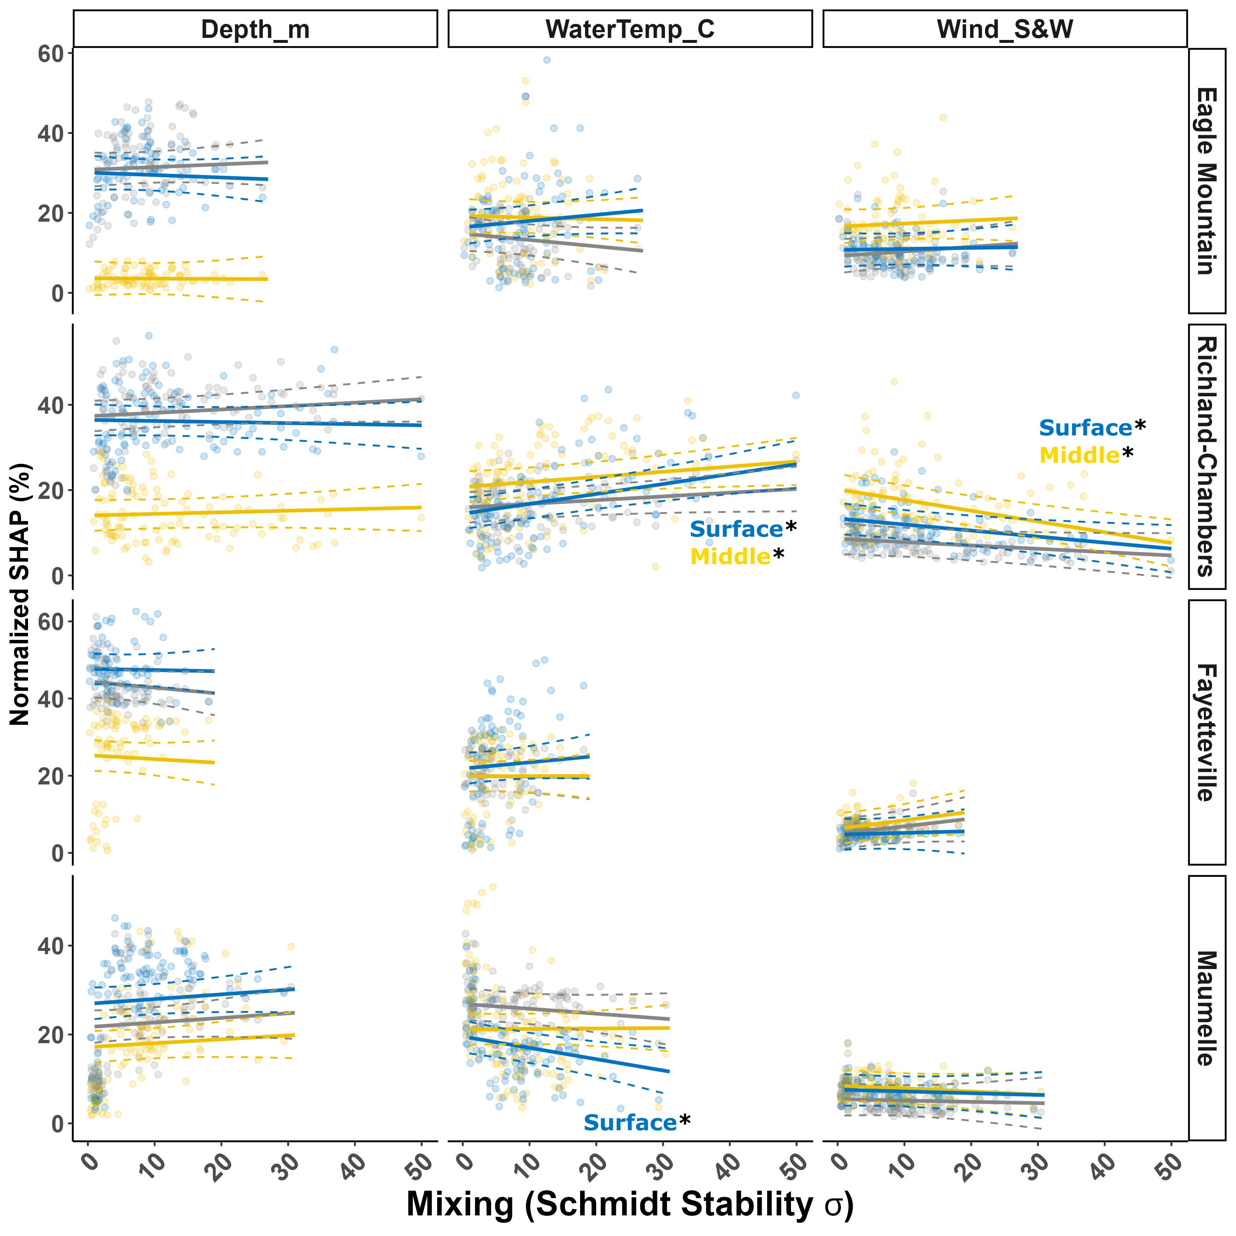

Fig. S2. Shapley Additive exPlanations (SHAP), aggregated across daily values, normalized as a percent contribution to the model dissolved oxygen (DO) prediction, for three primary variables we expected to be important across monomictic and polymictic reservoirs. Eagle Mountain and Richland-Chambers are polymictic, while Fayetteville and Maumelle are monomictic. SHAP given for predictions at the surface, middle (5 m) and bottom (8.5 - 10m; see Methods). Schmidt stability estimates the reservoir’s resistance to mixing, so we used the daily variability in Schmidt stability to detect days with large change in Schmidt stability. Significant slopes were only detected at the middle and surface depths of Eagle Mountain. Daily SHAP values (points) estimated slopes (solid lines), and 95% confidence intervals of slopes (dotted lines) are blue for surface, gold for middle, and grey for bottom.

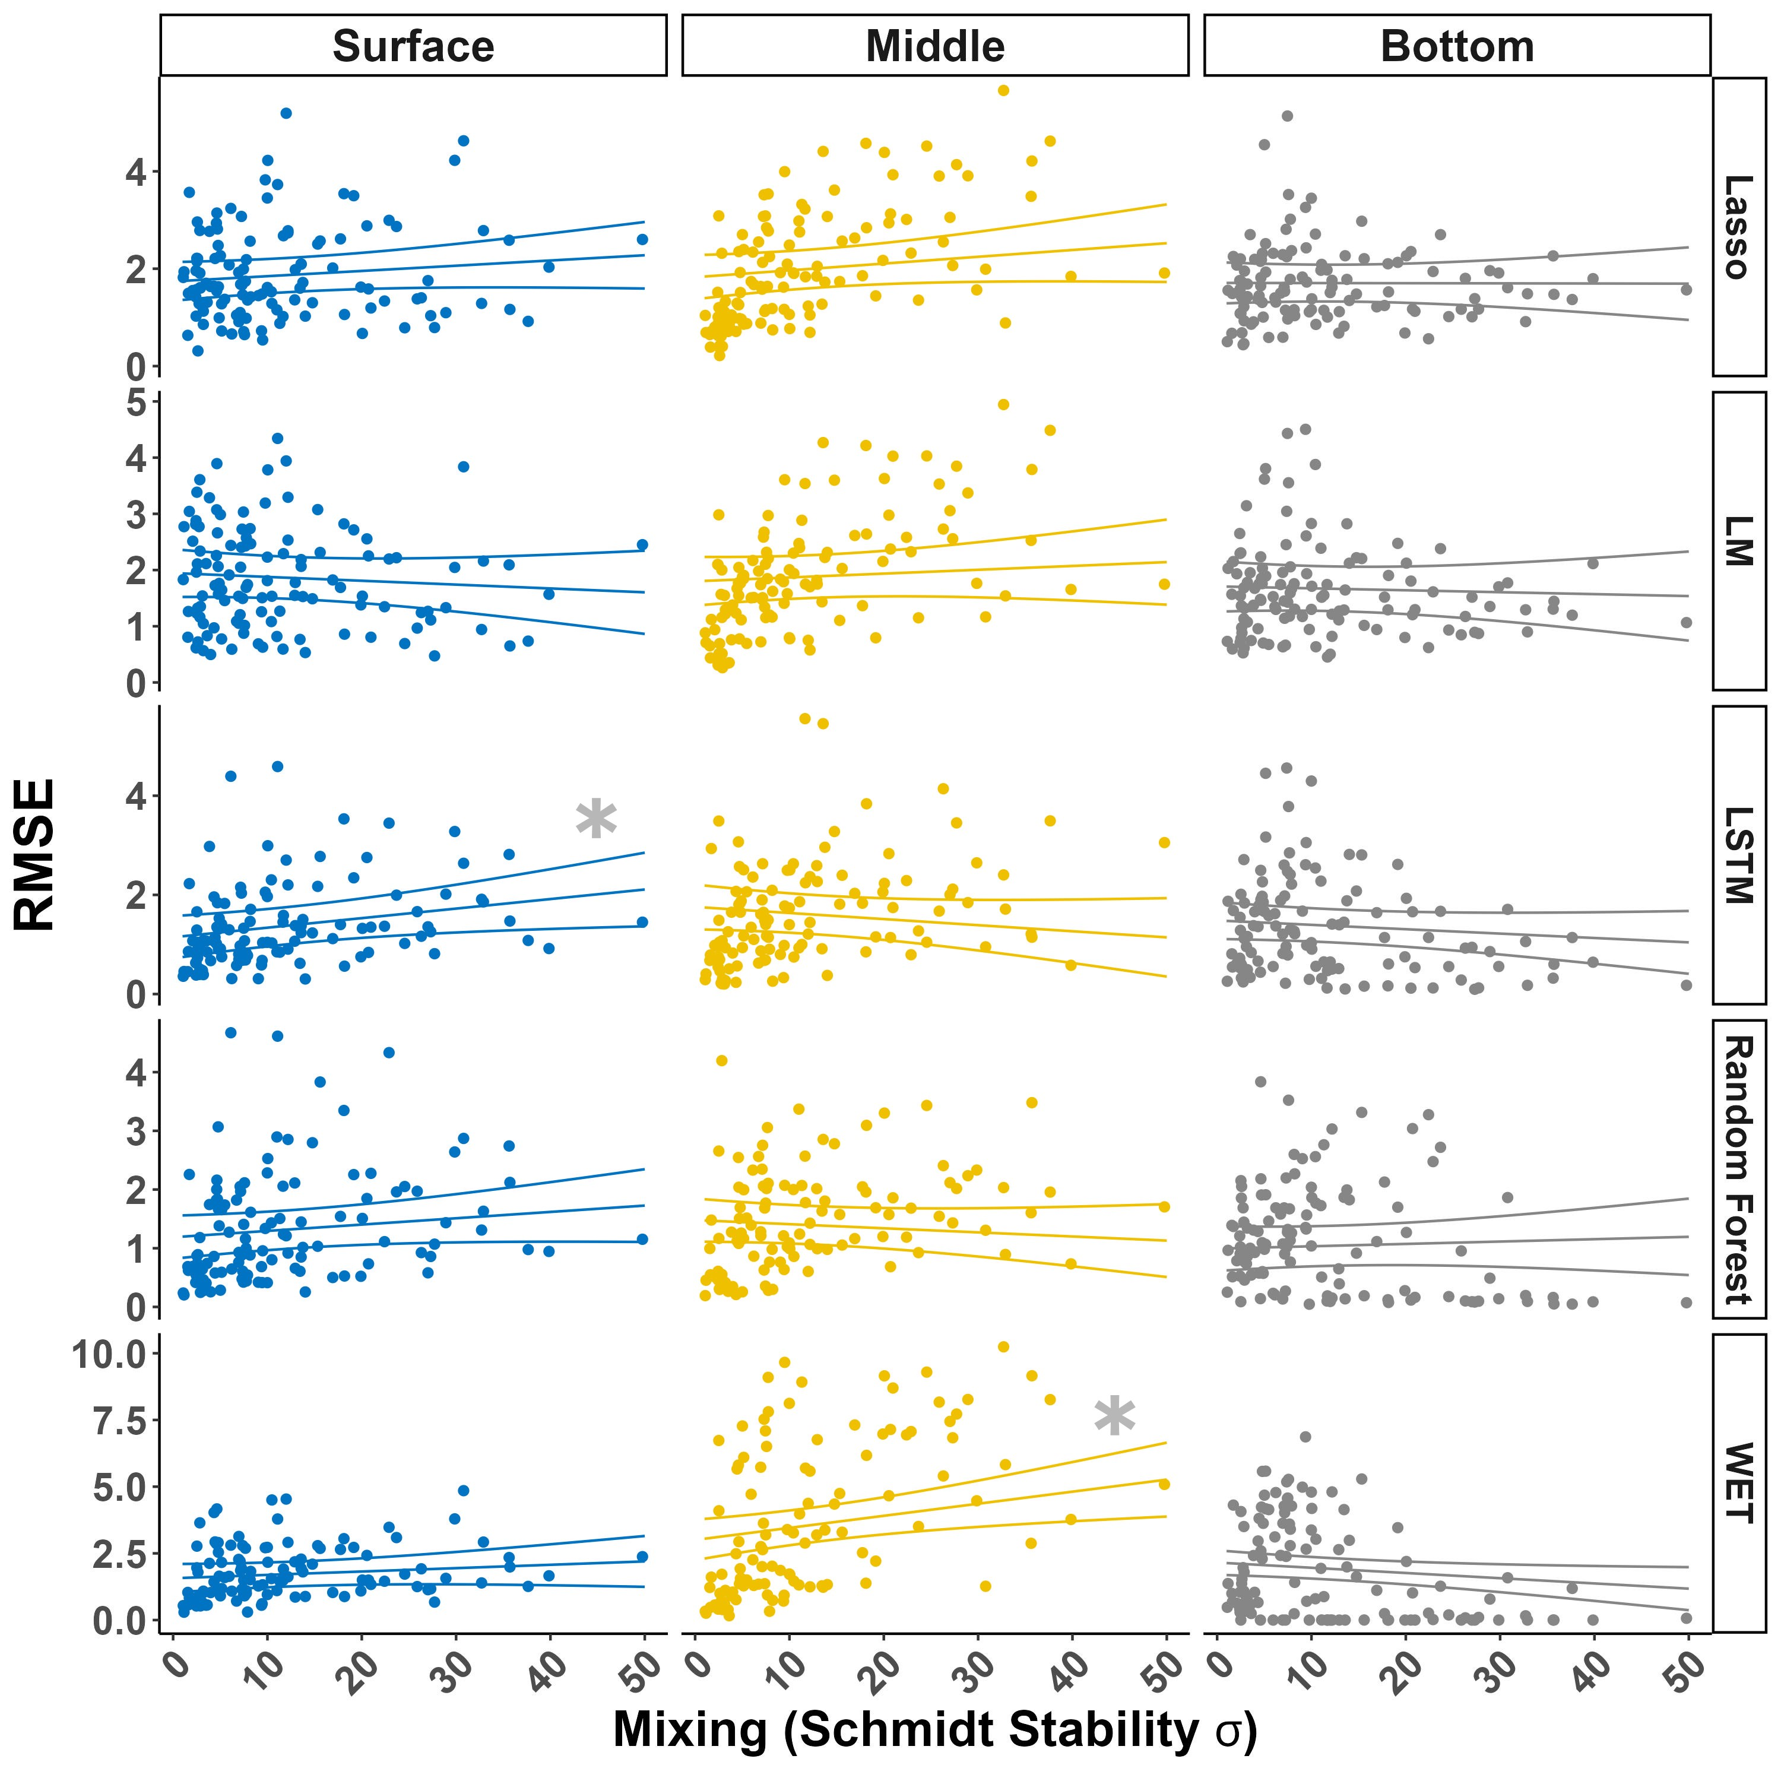

Fig. S3. Aggregated daily model RMSE from predictions of dissolved oxygen at the surface, middle (5 m) and bottom (10m) of Richland-Chambers reservoir for five different models. Models are Lasso regression, ordinary least squares regression (LM), Long short-term memory neural network (LSTM), Random Forest, and Water Ecosystems Tool (WET; a process-based model). Schmidt stability estimates the reservoir’s resistance to mixing, so we used the daily variability in Schmidt stability to detect days with large change in Schmidt stability. Lines are estimated slope and its 95% confidence intervals. Grey asterisks indicate significant (P<0.05) slopes.